**Assignment 6.2:**

**Dataset:**

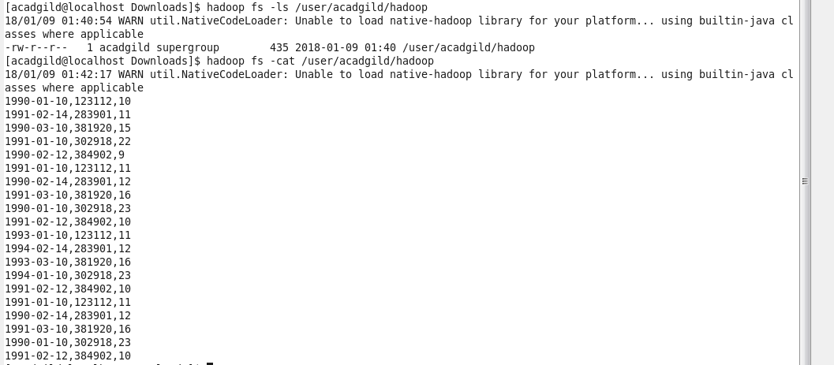

**Creating hive table ‘temperature_data’ and loading data in to this hive table using above given dataset:**

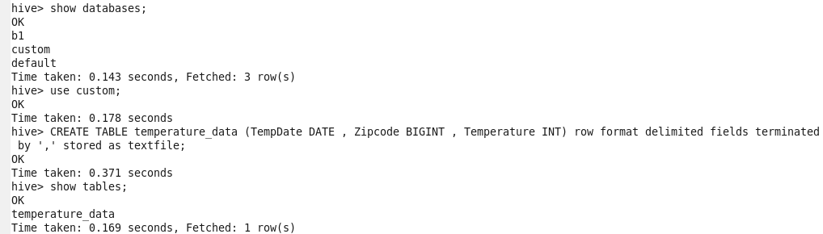

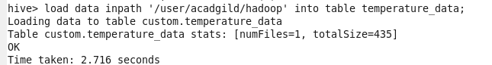

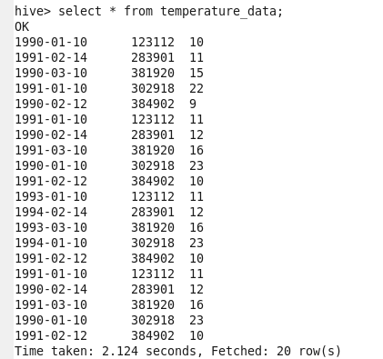

**Problem statement 1:**

Fetch date and temperature from temperature_data where zip code is greater than 300000 and less than 399999

**Output:**

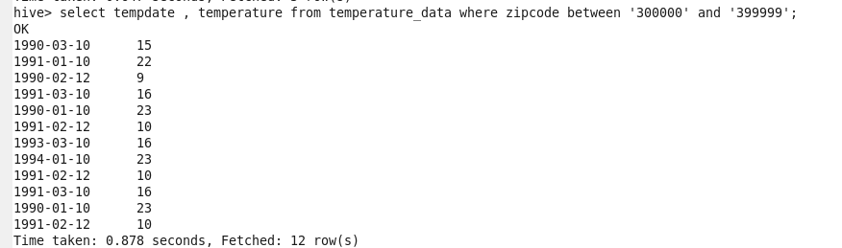

**Problem statement 2:**

Calculate maximum temperature corresponding to every year from temperature_data table



**Output:**

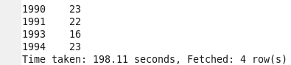

**Problem statement 3:**

Calculate maximum temperature from temperature_data table corresponding to those years which have at least 2 entries in the table.



**Output:**



**Problem statement 4:**

Create a view on the top of last query, name it as temperature_data_vw.

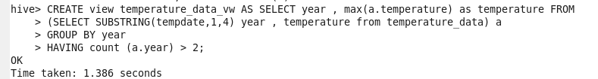

View is created successfully on top of last query.

Below snapshot to show contents of view created.

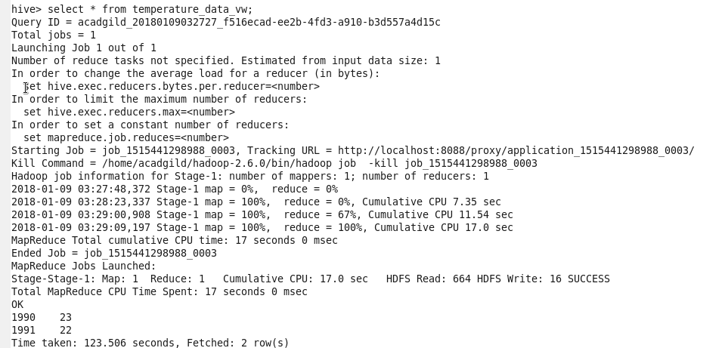

**Problem statement 5:**

Export contents from **temperature_data_vw** to a file in the local file system, such that each file is ‘|’ delimited.

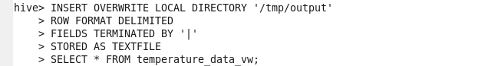

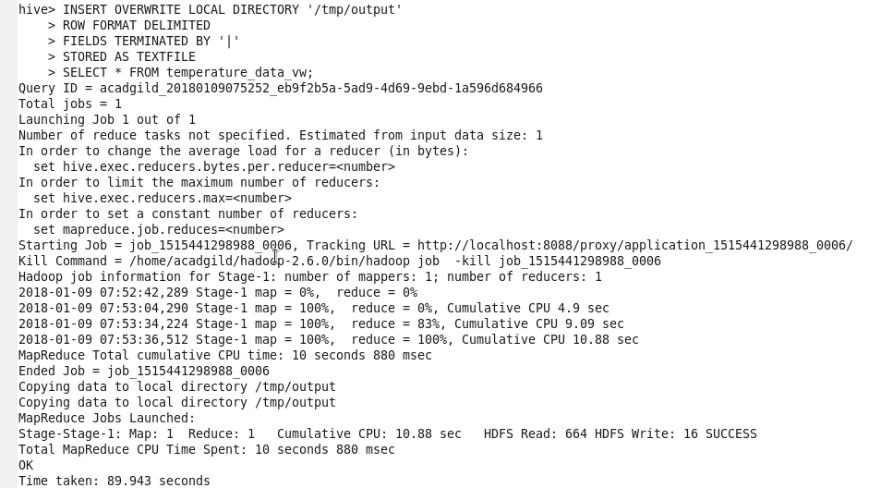

Here contents from **temperature_data_vw** is exported to a file in local file system.

Exported file is ‘|’ delimited.

